**Project** – **Movie database(movie_db) using SQL**

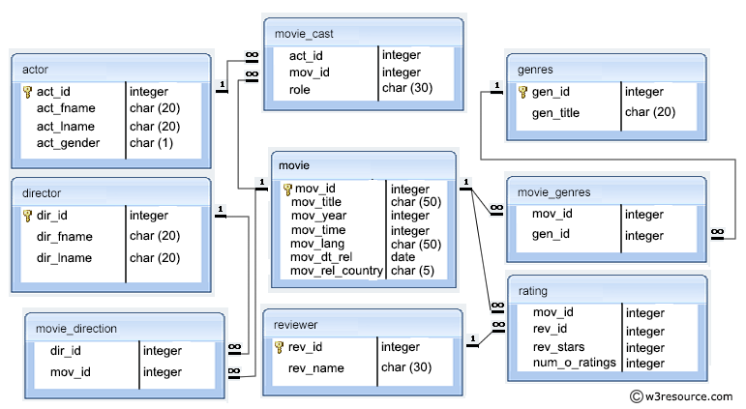

I have done this Project by using Xampp Control Panel, Command Prompt and using Browser to open local host admin page.

**Step by Step Guide**: -

* Firstly open the Xampp Control Panel and start the Apache Module and MySQL Module by clicking the start button in front of them.
* Open the localhost page of your Browser
* Open Command Prompt and change your directory address as per your details by using **cd\** command.
* Connect it with your admin page by using **mysql -h localhost -u root.**
* Create a database by using **create database;** command
* Now Create a database movie_db by using

**create database movie_dtb;**

1. **Created database movie_dtb**

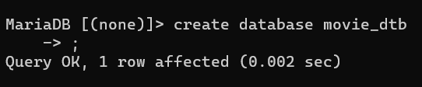

By using **show databases;** command you cancheck if the database has been created or not.

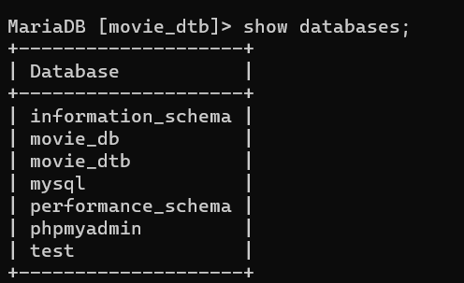

**Creation of tables inside movie_dtb database.**

1. **actor table**

**create table actor (act_id int Primary Key auto_increment,act_fname char(20),act_lname char(20),act_gender char(1));**

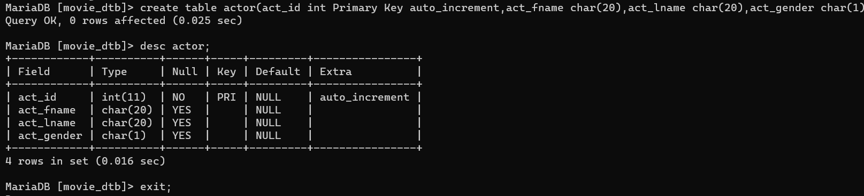

**Inserting values into actor**

**insert into actor values (1,"Aamir","Khan","M"),(2,"R.Madhavan","Ranganathan","M"),(3,"Sharman","Joshi","M"),(4,,"Kareena","Kapoor","F"),(5,"Boman","Irani","M"),(6,"Omi","Vaidya","M"),(7,"Akshay","Kumar","M"),(8,"Vidya","Balan","F"),(9,"Sanjay","Kapoor","M"),(10,"Sonakshi","Sinha","F"),(11,"Kirti","Kulhari","F"),(12,"Sunil","Dutt","M"),(13,"Sanjay","Dutt","M"),(14,"Gracy","Singh","F"),(15,"Arshad","Warsi","M"),(16,"Kurush","Deboo","M"),(17,"Darsheel","Safary","M"),(18,"Aamir","Khan","M"),(19,"Tisca","Chopra","F"),(20,"Rajan","Damodran","M"),(21,"Akshay","Kumar","M"),(22,"Sunil","Shetty","M"),(23,"Paresh","Rawal","M"),(24,"Bipasha","Basu","F"),(25,"Rajpal","Yadav","M");**

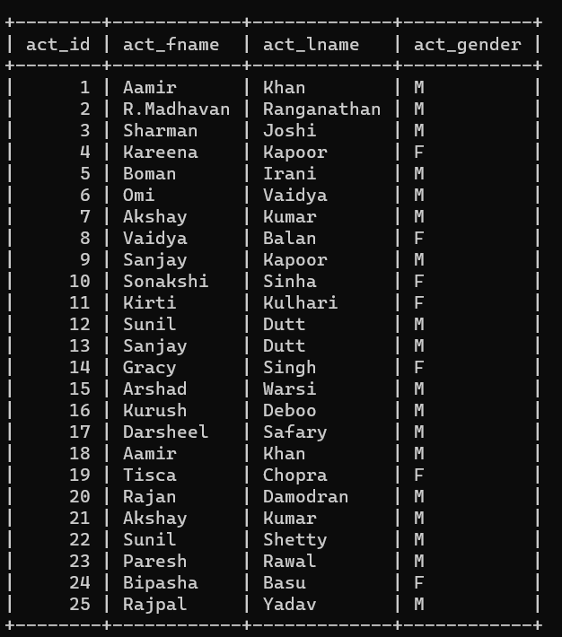

1. **director table**

**create table director(dir_id int Primary Key,dir_fname char(20),dir_lname char(20),dir_gender enum("M","F","Others"));**

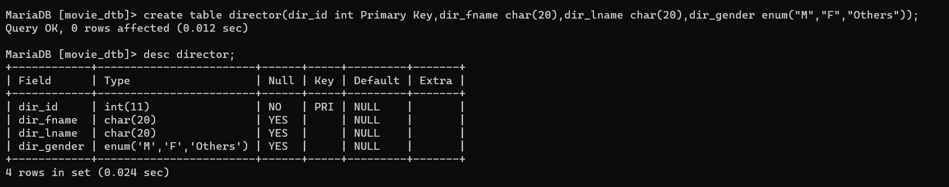

**Inserting values into director**

insert into director values **(1,"Rajkumar","Hirani","M"),(2,"Jagan","Shakti","F"),(3,"rajkumar","Hirani","M"),(4,"Aamir","Khan","M"),(5,"Neeraj","Vora","M");**

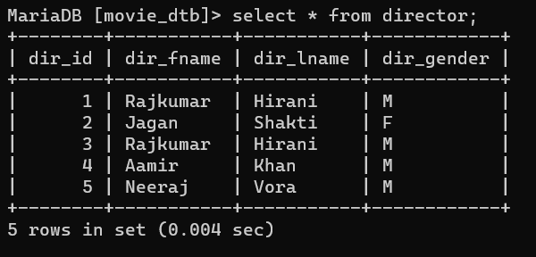

1. **movie_direction table**

**create table movie_direction(dir_id int,mov_id int);**



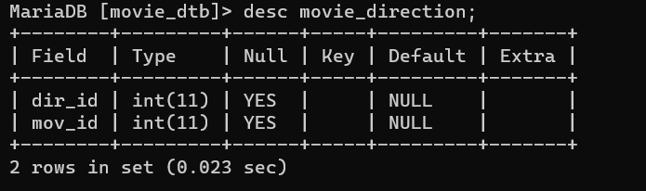

**Adding Foreign key in movie_direction**

1. **alter table movie_direction**

**->add foreign key(dir_id) references director(dir_id);**

**2) alter table movie_direction**

**-> add foreign key(mov_id) references movie(mov_id);**

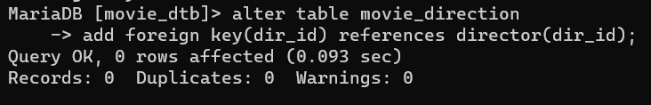

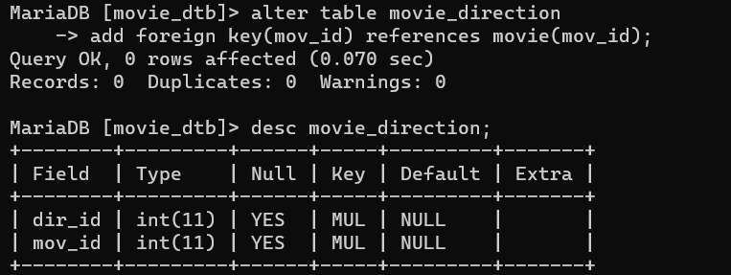

**Inserting values into movie_direction**

**insert into movie_direction values(1,1),(2,2),(3,3),(4,4),(5,5);**

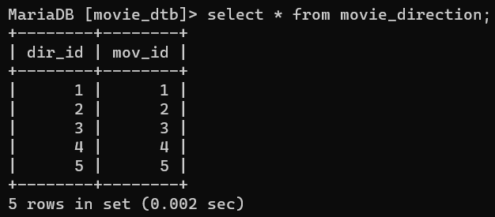

1. **movie_cast table**

**create table movie_cast(act_id int not null,mov_id int not null,role char(30) not null);**

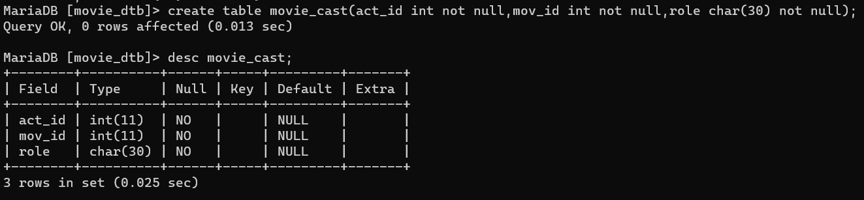

**Adding Foreign key in movie_direction**

**1) alter table movie_cast**

**-> add foreign key(act_id) references actor(act_id);**

**2) alter table movie_cast**

**-> add foreign key(mov_id) references movie(mov_id);**

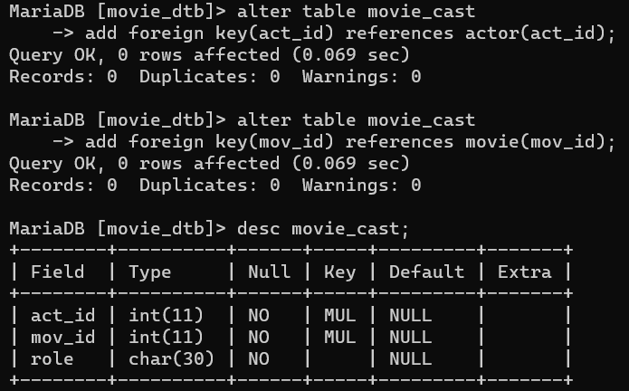

**Inserting values into movie_cast**

**insert into movie_cast values(1,1,"Hero"),(2,1,"Hero"),(3,1,"Hero"),(4,1,"Heroine"),(5,1,"Villain"),(6,1,"Villain"),(7,2,"Hero"),(8,2,"Heroine"),(9,2,"Hero"),(10,2,"Heroine"),(11,2,"Heroine"),(12,3,"Hero'sFather"),(13,3,"Hero"),(14,3,"Heroine"),(15,3,"Hero"),(16,3,"Side"),(17,4,"Hero"),(18,4,"Hero"),(19,4,"Hero'sMother"),(20,4,"Hero"),(21,5,"Hero"),(22,5,"Hero"),(23,5,"Hero"),(24,5,"Heroine"),(25,5,"Villain");**

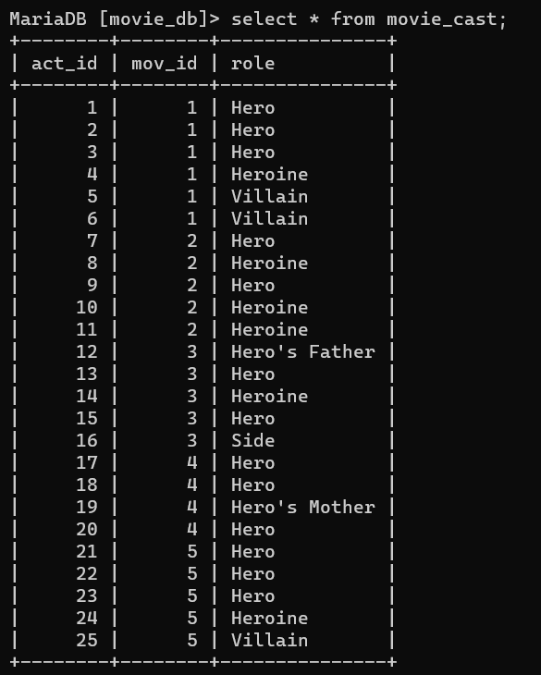

1. **movie table**

**create table movie(mov_id int Primary key,mov_title char(50) not null,mov_year int not null,mov_time int not null,mov_lang char(50) not null,mov_dt_rel date not null,mov_rel_country char(5) not null);**

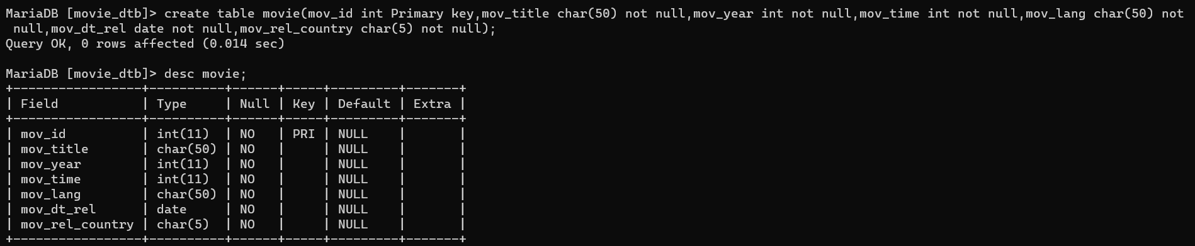

**Inserting values into movie**

**insert into movie values(1,"3 Idiots",2009,"170 min","Hindi","2009-12-25","India"),(2,"Mission Mangal",2019,"127 min","Hindi","2019-08-15","India"),(3,"Munna Bhai M.B.B.S",2003,"157 min","Hindi","2003-12-19","India"),(4,"Taare Zameen Par",2007,"164 min","Hindi","2007-12-21","India"),(5,"Phir Hera Pheri",2006,"153 min","Hindi","2006-06-09","India");**

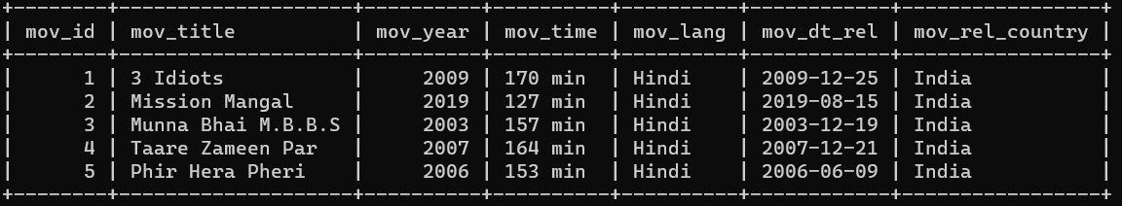

1. **reviewer table**

**create table reviewer(rev_id int Primary key,rev_name char(30));**

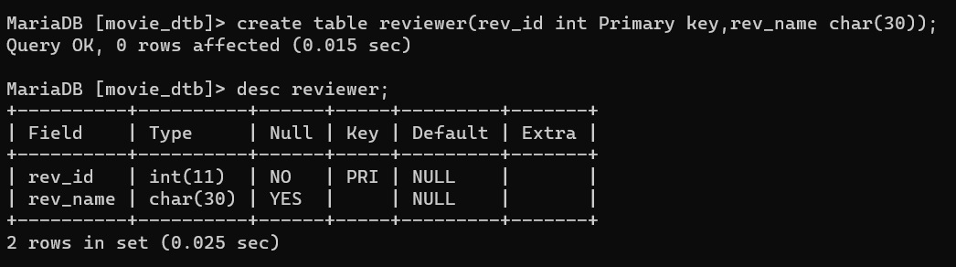

**Insert into reviewer values (1,"Rohan"),(2,"Viraj"),(3,"Kartik"),(4,"Vishal"),(5,"Rahul"),(6,"Raj"),(7,"Harsh"),(8,"Kartik"),(9,"Raghav"),(10,"Vishal"),(11,"Alas"),(12,"Riya"),(13,"Priya"),(14,"Remo"),(15,"Nitin"),(16,"Vipul"),(17,"Ishwar"),(18,"Vaibhav"),(19,"Mahesh"),(20,"Omkar"),(21,"Rahul"),(22,"Abhi"),(23,"Vivek"),(24,"Rutik"),(25,"Santosh");**

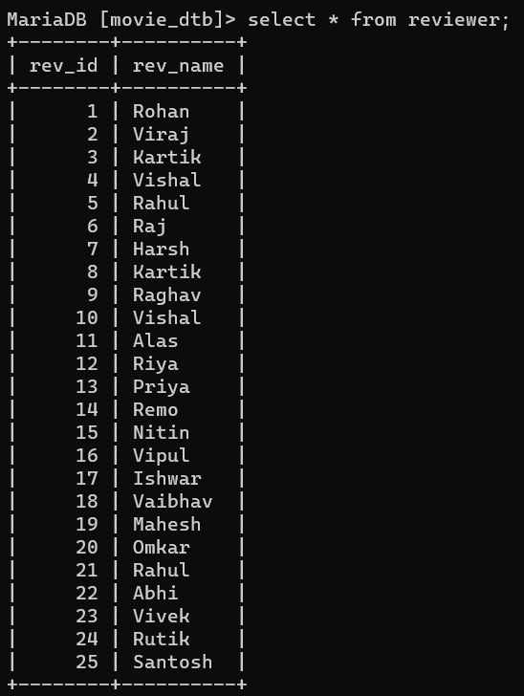

1. **genres table**

**create table genres(gen_id int Primary key,gen_title char(20));**



**Inserting values into genres**

**insert into genres values(1,”Comedy,Romance,Drama”),(2,”Drama,Science Fiction”),(3,”Comedy,Drama”),(4,”Comedy”),(5,”Comedy”);**

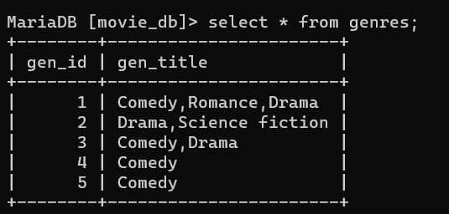

1. **movie_genres**

**create table movie_genres(mov_id int not null,gen_id int not null);**

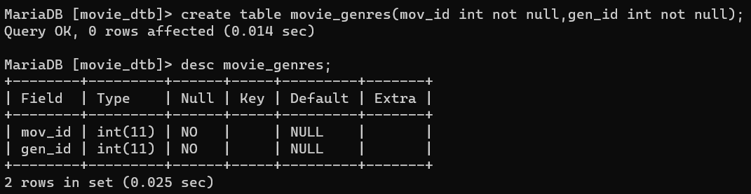

**Adding Foreign key in movie_genres**

**1) alter table movie_genres**

**-> add foreign key(mov_id) references movie(mov_id);**

**2) alter table movie_genres**

**-> add foreign key(gen_id) references genres(gen_id);**

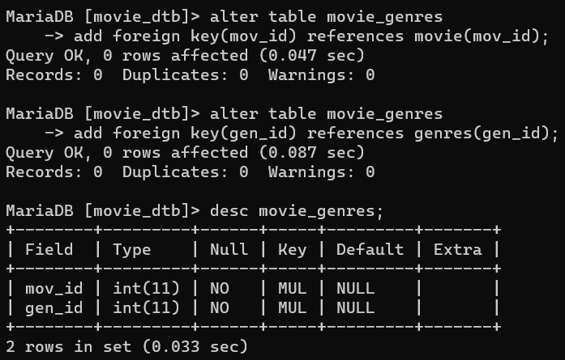

**Inserting values into movie_genres**

**insert into movie_genres values(1,1),(2,2),(3,3),(4,4),(5,5);**

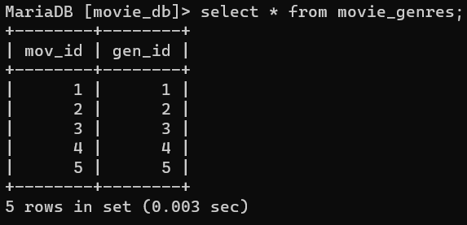

1. **rating**

**create table rating(mov_id int not null,rev_id int not null,rev_stars int not null,num_of_ratings int not null);**

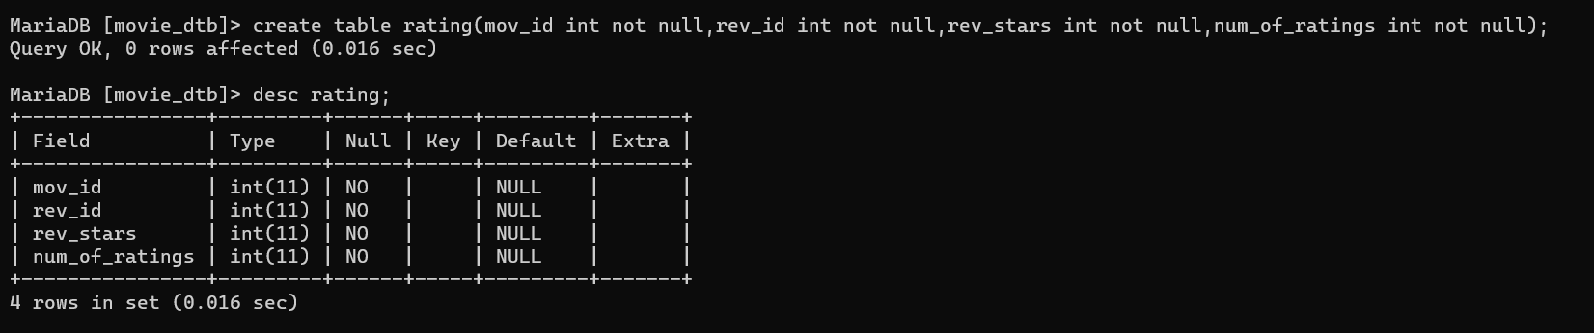

**Adding Foreign key in rating**

1. **alter table rating**

**-> add foreign key(mov_id) references movie(mov_id);**

1. **alter table rating**

**-> add foreign key(rev_id) references reviewer(rev_id);**

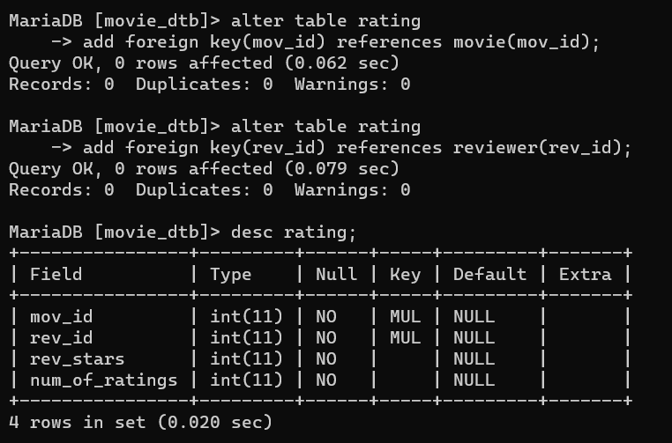

**Inserting into rating values**

**insert into rating values(1,1,4.5,50,"A great movie with a meaningful message"),(1,2,4.7,10,"One of the best Bollywood movies ever!"),(1,3,5,100,"Loved every moment of the movie"),(1,4,3.5,20,"Not as good as expected,but still decent"),(1,5,4.5,500,"Awesome movie"),(2,6,4.5,500,"A fantastic movie showcasing teamwork and science"),(2,7,4.8,750,"Inspirational and well executed film"),(2,8,3.5,50,"Interesting story but some pacing issues"),(2,9,4,100,"Great performances by the cast"),(2,10,5,1000,"A must watch for space enthusiasts"),(3,11,4.5,100,"Heartwarming and hilarious movie"),(3,12,4.8,200,"Iconic performances and memorable dialogues"),(3,13,3.5,100,"Entertaining but some parts feel unrealistic"),(3,14,5,500,"One of Bollywoods best comedies"),(3,15,4.6,100,"Munna Bhai'scharacter is unforgettable"),(4,16,4.9,100,"A beautiful and touching film"),(4,17,4.2,50,"Heartfelt and thought provoking"),(4,18,4.5,20,"Outstanding performances especially by the child actor"),(4,19,5,200,"A masterpiece that brings tears to your eyes"),(4,20,4.8,10,"One of the most emotional movies ever"),(5,21,4.5,200,"Hilarious sequel with a great cast"),(5,22,4.8,500,"Laugh-out-loud moments throughout the film"),(5,23,3.2,20,"Entertaining, but lacks the freshness of the original"),(5,24,4,50,"Good performances but the plot could be better"),(5,25,4,100,"Good performances, but the plot could be better");**

